Nonagonal Bipyramid

Definition
# Source: AI Source: Provided by: [Data Path: Persons Table -> ID Column: 1, Name_En Column: Motasem Essam] -> From: [ChatGPT] on [7/25/2026]
A Nonagonal Bipyramid is a three-dimensional polyhedron formed by joining two nonagonal pyramids at their congruent nonagonal bases. The shared nonagonal base becomes an internal face, while the triangular lateral faces form the exterior surface.
It consists of:
- Two apexes positioned on opposite sides of a common nonagonal base.
- Nine vertices forming the shared nonagonal base.
- Eighteen external triangular faces.
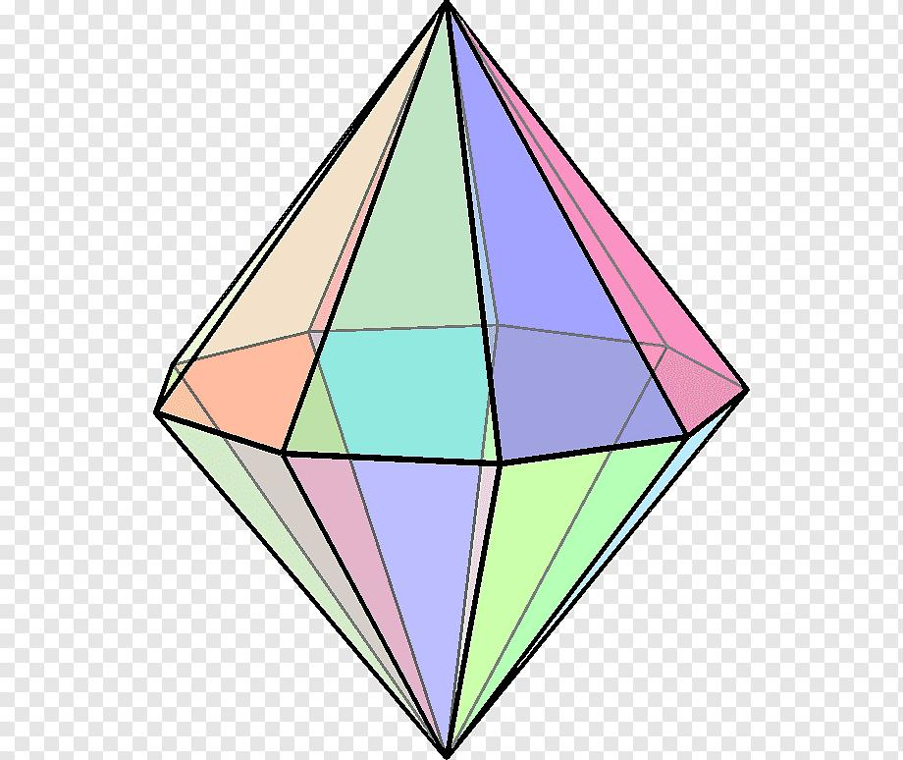

Simple Definition
# Source: AI Source: Provided by: [Data Path: Persons Table -> ID Column: 1, Name_En Column: Motasem Essam] -> From: [ChatGPT] on [7/25/2026]
A nonagonal bipyramid is a solid made by joining two nonagonal pyramids base-to-base, creating a polyhedron with 18 triangular faces, 27 edges, and 11 vertices.

Geometric Structure
# Source: AI Source: Provided by: [Data Path: Persons Table -> ID Column: 1, Name_En Column: Motasem Essam] -> From: [ChatGPT] on [7/25/2026]
The nonagonal bipyramid has three main structural components:
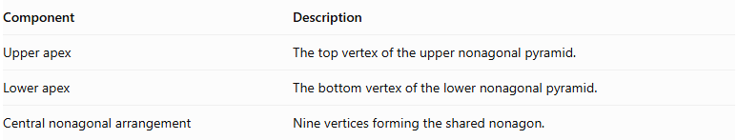
Component | Description
Upper apex | The top vertex of the upper nonagonal pyramid.
Lower apex | The bottom vertex of the lower nonagonal pyramid.
Central nonagonal arrangement | Nine vertices forming the shared nonagon.
Both apexes are connected to all nine vertices of the central nonagon.

Face Structure
# Source: AI Source: Provided by: [Data Path: Persons Table -> ID Column: 1, Name_En Column: Motasem Essam] -> From: [ChatGPT] on [7/25/2026]
A nonagonal bipyramid has 18 external triangular faces.
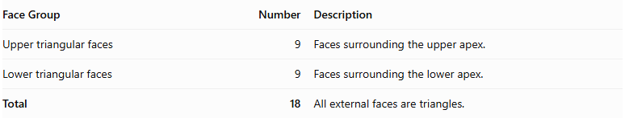
Face Group | Number | Description
Upper triangular faces | 9 | Faces surrounding the upper apex.
Lower triangular faces | 9 | Faces surrounding the lower apex.
Total | 18 | All external faces are triangles.
The common nonagonal base is internal, so it is not counted as an external face.

Edge Structure
# Source: AI Source: Provided by: [Data Path: Persons Table -> ID Column: 1, Name_En Column: Motasem Essam] -> From: [ChatGPT] on [7/25/2026]
The solid has 27 edges, divided into three groups:
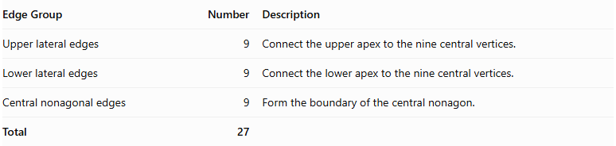
Edge Group | Number | Description
Upper lateral edges | 9 | Connect the upper apex to the nine central vertices.
Lower lateral edges | 9 | Connect the lower apex to the nine central vertices.
Central nonagonal edges | 9 | Form the boundary of the central nonagon.
Total | 27

Vertex Structure
# Source: AI Source: Provided by: [Data Path: Persons Table -> ID Column: 1, Name_En Column: Motasem Essam] -> From: [ChatGPT] on [7/25/2026]
A nonagonal bipyramid has 11 vertices.
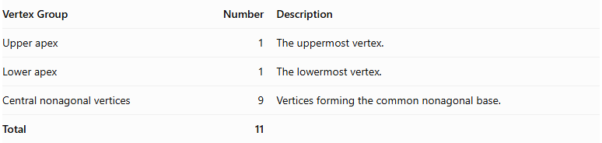
Vertex Group | Number | Description
Upper apex | 1 | The uppermost vertex.
Lower apex | 1 | The lowermost vertex.
Central nonagonal vertices | 9 | Vertices forming the common nonagonal base.
Total | 11

Mathematical Properties
# Source: AI Source: Provided by: [Data Path: Persons Table -> ID Column: 1, Name_En Column: Motasem Essam] -> From: [ChatGPT] on [7/25/2026]
For a nonagonal bipyramid:
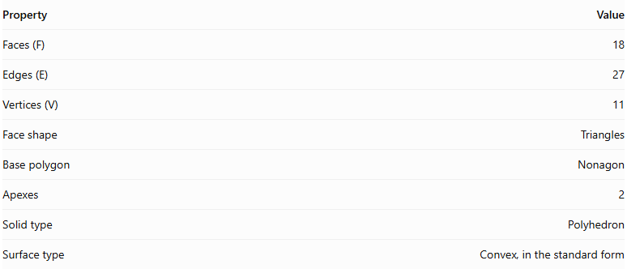
Property | Value
Faces (F) | 18
Edges (E) | 27
Vertices (V) | 11
Face shape | Triangles
Base polygon | Nonagon
Apexes | 2
Solid type | Polyhedron
Surface type | Convex, in the standard form
It satisfies Euler's polyhedron formula:
$$V-E+F=2$$
$$11-27+18=2$$

Face Incidence
# Source: AI Source: Provided by: [Data Path: Persons Table -> ID Column: 1, Name_En Column: Motasem Essam] -> From: [ChatGPT] on [7/25/2026]
In the standard nonagonal bipyramid:
- Each apex is shared by 9 triangular faces.
- Each central nonagonal vertex is shared by 4 triangular faces.

Surface Area and Volume

Surface Area
# Source: AI Source: Provided by: [Data Path: Persons Table -> ID Column: 1, Name_En Column: Motasem Essam] -> From: [ChatGPT] on [7/25/2026]
The total surface area is the sum of the areas of the eighteen external triangular faces.
$$SA=9A_{u}+9A_{l}$$
Where:
- $A_{u}$ = area of one upper triangular face.
- $A_{l}$ = area of one lower triangular face.
If the upper and lower pyramids are congruent:
$$SA=18A_{t}$$
For a nonagonal bipyramid with identical triangular faces, where each triangle has base side length $s$ and slant height $l$:
$$SA=18(\frac{1}{2}sl)$$
$$\boxed{SA=9sl}$$

Volume
# Source: AI Source: Provided by: [Data Path: Persons Table -> ID Column: 1, Name_En Column: Motasem Essam] -> From: [ChatGPT] on [7/25/2026]
The volume is the sum of the volumes of the two nonagonal pyramids.
$$V=\frac{1}{3}{Bh}_{u}+\frac{1}{3}{Bh}_{l}$$
Therefore:
$$\boxed{V=\frac{1}{3}B(h_{u}+h_{l})}$$
Where:
- $B$ = area of the common nonagonal base.
- $h_{u}$ = height of the upper pyramid.
- $h_{l}$ = height of the lower pyramid.
For a regular nonagonal base with side length $s$:
$$B=\frac{9s^{2}}{4tan(π/9)}$$
Therefore:
$$\boxed{V=\frac{3s^{2}}{4tan(π/9)}(h_{u}+h_{l})}$$

Symmetry
# Source: AI Source: Provided by: [Data Path: Persons Table -> ID Column: 1, Name_En Column: Motasem Essam] -> From: [ChatGPT] on [7/25/2026]
A regular nonagonal bipyramid with congruent upper and lower pyramids has the following symmetries:
- Ninefold rotational symmetry: Rotation by ${40}^{∘}$ around the central axis maps the solid onto itself.
- Vertical reflection planes: Nine planes pass through the central axis and the central nonagonal arrangement.
- Horizontal reflection plane: The central nonagonal plane reflects the upper half onto the lower half.
- Central inversion symmetry: Each point has a corresponding opposite point through the solid's center.

Relationship to Other Solids
# Source: AI Source: Provided by: [Data Path: Persons Table -> ID Column: 1, Name_En Column: Motasem Essam] -> From: [ChatGPT] on [7/25/2026]
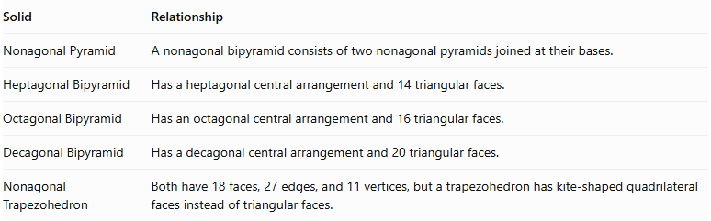
Solid | Relationship
Nonagonal Pyramid | A nonagonal bipyramid consists of two nonagonal pyramids joined at their bases.
Heptagonal Bipyramid | Has a heptagonal central arrangement and 14 triangular faces.
Octagonal Bipyramid | Has an octagonal central arrangement and 16 triangular faces.
Decagonal Bipyramid | Has a decagonal central arrangement and 20 triangular faces.
Nonagonal Trapezohedron | Both have 18 faces, 27 edges, and 11 vertices, but a trapezohedron has kite-shaped quadrilateral faces instead of triangular faces.

Worked Examples

Example 1: Calculate the Number of Faces, Edges, and Vertices
# Source: AI Source: Provided by: [Data Path: Persons Table -> ID Column: 1, Name_En Column: Motasem Essam] -> From: [ChatGPT] on [7/25/2026]
Given: A nonagonal bipyramid has a nonagonal central arrangement.
For an $n$-gonal bipyramid:
$$F=2n, E=3n, V=n+2$$
Since $n=9$:
$$F=2(9)=18$$
$$E=3(9)=27$$
$$V=9+2=11$$
Answer:
- Faces = 18
- Edges = 27
- Vertices = 11

Example 2: Calculate the Volume
# Source: AI Source: Provided by: [Data Path: Persons Table -> ID Column: 1, Name_En Column: Motasem Essam] -> From: [ChatGPT] on [7/25/2026]
Given:
- Area of the nonagonal base: $B=120{ cm}^{2}$
- Upper pyramid height: $h_{u}=15 cm$
- Lower pyramid height: $h_{l}=12 cm$
Using:
$$V=\frac{1}{3}B(h_{u}+h_{l})$$
Substitute:
$$V=\frac{1}{3}(120)(15+12)$$
$$V=\frac{3240}{3}$$
$$\boxed{V=1080{ cm}^{3}}$$

Constructing Nonagonal Bipyramid in Solid Geometry

Geometric Instruments Used
# Source: AI Source: Provided by: [Data Path: Persons Table -> ID Column: 1, Name_En Column: Motasem Essam] -> From: [ChatGPT] on [7/25/2026]
The construction uses traditional geometric instruments rather than coordinate-based construction.
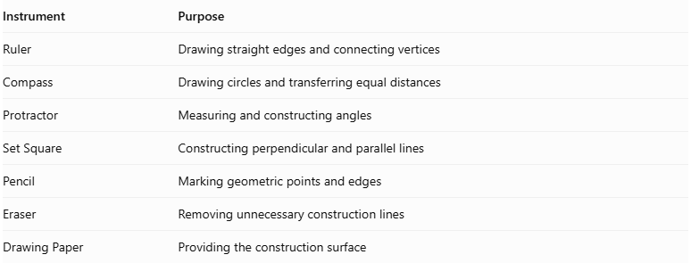
Instrument | Purpose
Ruler | Drawing straight edges and connecting vertices
Compass | Drawing circles and transferring equal distances
Protractor | Measuring and constructing angles
Set Square | Constructing perpendicular and parallel lines
Pencil | Marking geometric points and edges
Eraser | Removing unnecessary construction lines
Drawing Paper | Providing the construction surface

Instrument-Based Construction Procedures

Constructing the Nonagonal Base
# Source: AI Source: Provided by: [Data Path: Persons Table -> ID Column: 1, Name_En Column: Motasem Essam] -> From: [ChatGPT] on [7/25/2026]
- Draw a circle using a compass.
- Mark the center of the circle.
- Divide the circle into nine equal angular sections using a protractor.
- Each central angle measures:
$$\frac{{360}^{∘}}{9}={40}^{∘}$$
- Mark the nine points around the circumference.
- Connect consecutive points using a ruler.
- Complete the regular nonagonal base.

Constructing the First Pyramid
# Source: AI Source: Provided by: [Data Path: Persons Table -> ID Column: 1, Name_En Column: Motasem Essam] -> From: [ChatGPT] on [7/25/2026]
- Identify the center of the nonagonal base.
- Construct a perpendicular line passing through the center of the base.
- Mark the first apex above the base plane.
- Connect the apex to all nine vertices of the nonagon.
- Form nine triangular lateral faces.

Constructing the Second Pyramid
# Source: AI Source: Provided by: [Data Path: Persons Table -> ID Column: 1, Name_En Column: Motasem Essam] -> From: [ChatGPT] on [7/25/2026]
- Extend the perpendicular axis through the base plane in the opposite direction.
- Mark the second apex below the base plane.
- Connect the second apex to all nine vertices of the nonagon.
- Form another nine triangular lateral faces.

Completing the Bipyramid
# Source: AI Source: Provided by: [Data Path: Persons Table -> ID Column: 1, Name_En Column: Motasem Essam] -> From: [ChatGPT] on [7/25/2026]
- Check that both pyramids share the same nonagonal base.
- Ensure that the two apices are on opposite sides of the base plane.
- Darken the visible external edges.
- Represent hidden edges using dashed lines when necessary.
- Remove unnecessary construction marks.

Key Points
# Source: AI Source: Provided by: [Data Path: Persons Table -> ID Column: 1, Name_En Column: Motasem Essam] -> From: [ChatGPT] on [7/25/2026]
- A nonagonal bipyramid is formed by joining two nonagonal pyramids at their bases.
- It has 18 external triangular faces.
- It has 27 edges.
- It has 11 vertices.
- Its common nonagonal base is internal and is not counted as an external face.
- Its volume is the sum of the volumes of the two nonagonal pyramids.
- A regular symmetric nonagonal bipyramid has ninefold rotational symmetry.

Conclusion
# Source: AI Source: Provided by: [Data Path: Persons Table -> ID Column: 1, Name_En Column: Motasem Essam] -> From: [ChatGPT] on [7/25/2026]
The Nonagonal Bipyramid is a polyhedron formed by combining two nonagonal pyramids around a shared nonagonal base. It belongs to the family of $n$-gonal bipyramids and has 18 triangular faces, 27 edges, and 11 vertices.
Its defining characteristic is the nine-sided central arrangement connecting the upper and lower apexes.

